GPS Spoofing Demonstration Using HackRF One & DragonOS
Aviation Security Research Report

1. Introduction
Global Navigation Satellite Systems (GNSS), especially GPS, form a critical component of modern aviation. Aircraft depend heavily on GPS for navigation, positioning, and timing.
However, in recent years, GPS spoofing attacks have increased globally, affecting navigation systems of both civilian and commercial aircraft.
This report presents a controlled, demonstration of how GPS spoofing can work using a Software Defined Radio (SDR) platform — specifically HackRF One and GPS-SDR-SIM — to simulate the effect of a spoofed GPS signal near Indira Gandhi International (IGI) Airport, Delhi.
⚠️ Disclaimer:
This experiment was conducted strictly in an isolated, non-radiating test environment.
The intent is to raise awareness of aviation GNSS vulnerabilities for cybersecurity research and education.

2. Tools & Technologies Used
- DragonOS (Linux-based SDR distribution)
- HackRF One with Mayhem Firmware
- GPS-SDR-SIM (GPS signal simulator)
- NASA CDDIS Ephemeris (BRDC) files
- GCC Compiler
- GPS Antenna (Test Environment Only)
- HackRF host utilities (hackrf_transfer)

3. Objective of the Demonstration
The objective of this research is to:
- Demonstrate how a spoofed GPS signal can be generated using openly available data.
- Show the risk spoofed GPS signals pose to aviation systems dependent on GNSS.
- Highlight the importance of implementing GNSS anti-spoofing and authentication techniques.
The demonstration simulates a GPS signal that appears to come from the coordinates of IGI Airport, New Delhi.

4. Installing & Preparing the Environment
4.1 DragonOS
DragonOS is used due to its pre-installed SDR tools, libraries, and compatibility with HackRF.
Boot into DragonOS and ensure basic SDR utilities are working.

5. Downloading & Compiling GPS-SDR-SIM
5.1 Clone GPS-SDR-SIM
“git clone https://github.com/osqzss/gps-sdr-sim.git”
5.2 Compile the C Source Code
Navigate into the cloned directory and run:
“gcc gpssim.c -lm -O3 -o gps-sdr-sim”
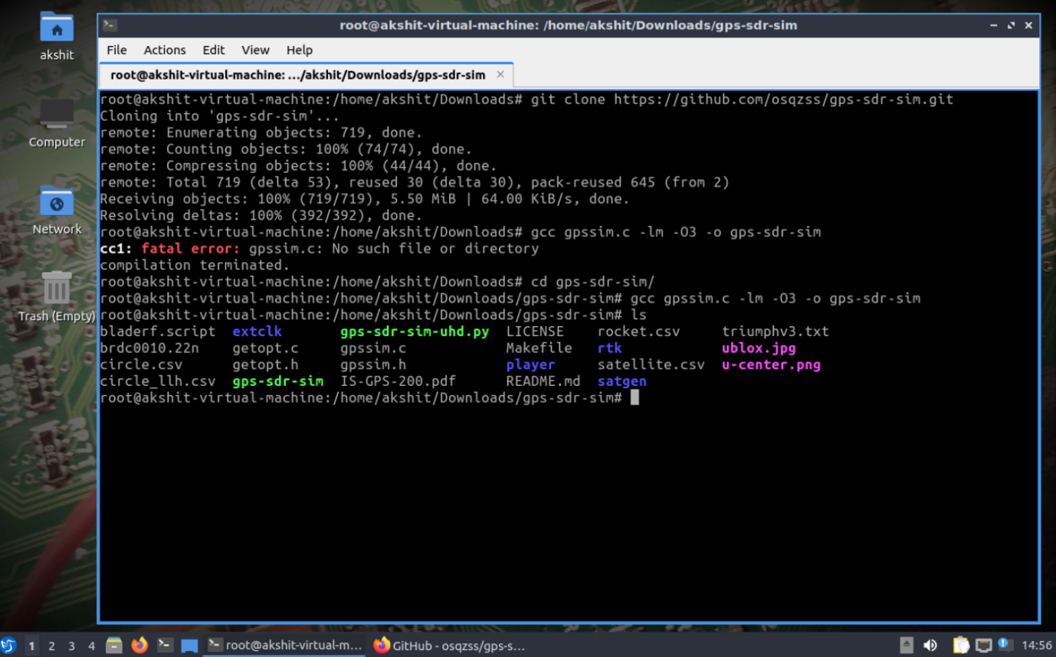
This generates the executable gps-sdr-sim.

6. Downloading GPS Ephemeris Data (BRDC File)
6.1 What is an Ephemeris File?
NASA maintains daily GPS satellite broadcast navigation data known as Ephemeris (RINEX Navigation Files).
These provide satellite:
- Position
- Time
- Pseudo-range
- Doppler shifts
GPS-SDR-SIM uses this data to generate realistic spoofing waveforms.
6.2 Downloading the Latest File
- Create/login to your Earthdata account:
https://urs.earthdata.nasa.gov/login
- Navigate to the daily GNSS archive:
https://cddis.nasa.gov/archive/gnss/data/daily/
Example file used:
brdc3190.25n.gz
6.3 Extract the File
gzip -d brdc3190.25n.gz
This extracts:
brdc3190.25n
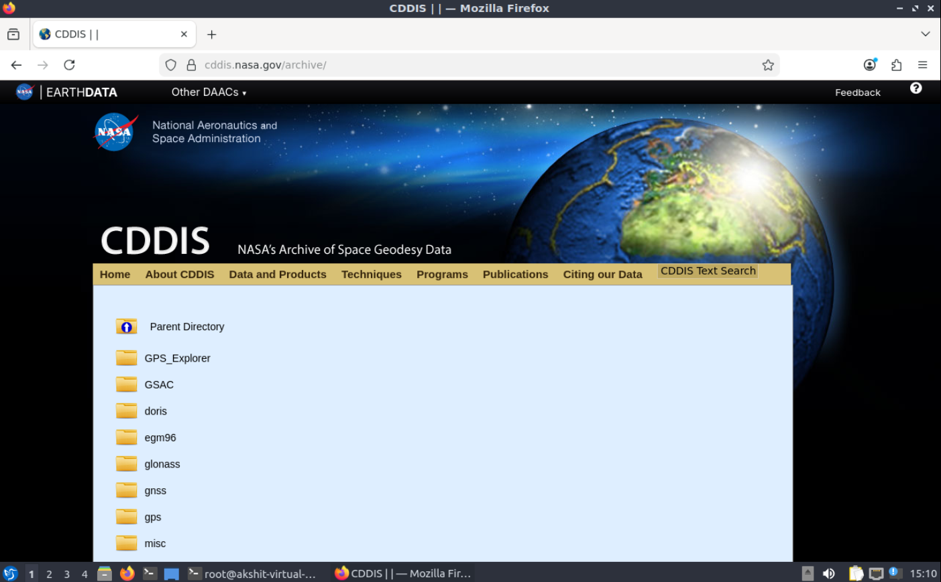
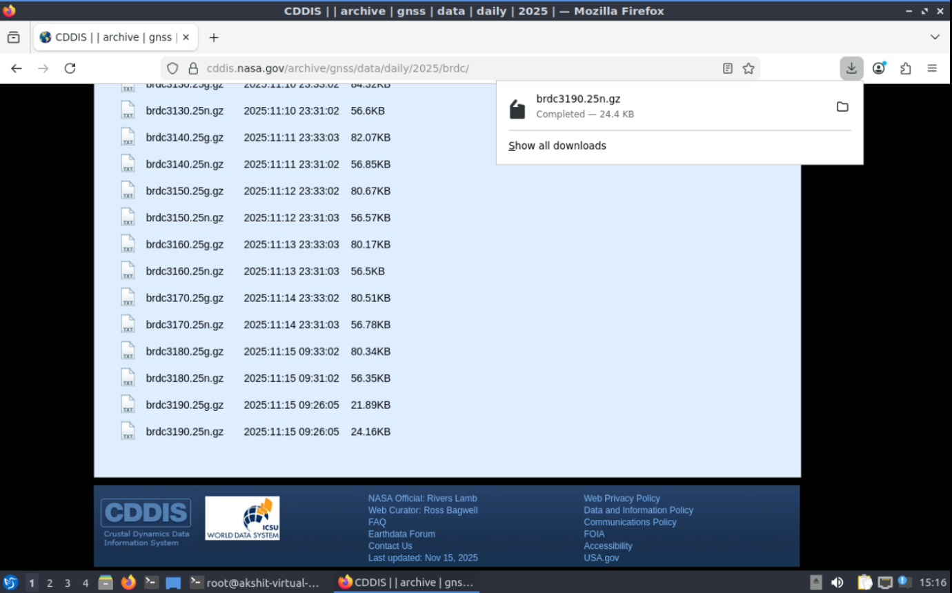
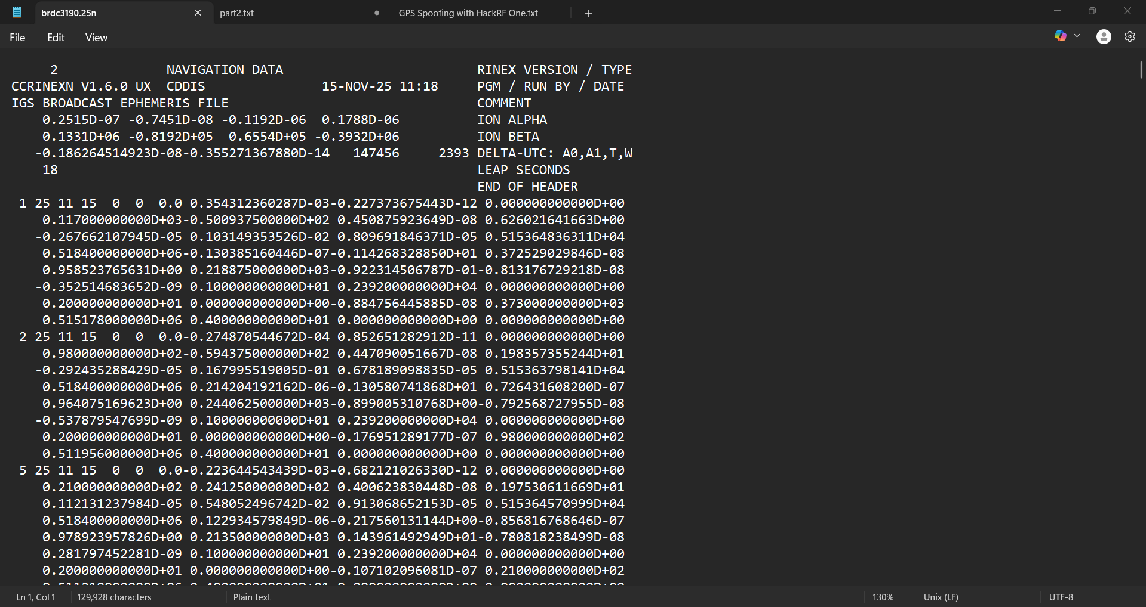

7. Generating the Spoofed GPS Signal
We generate the I/Q samples needed for HackRF transmission.
7.1 Command to Generate gpssim.bin
“./gps-sdr-sim -e brdc3190.25n -l 28.556276,77.100662,100 -b 8”
Where:
- 28.556276 = Latitude of IGI Airport
- 77.100662 = Longitude of IGI Airport
- 100 meters = Altitude
- -b 8 = 8-bit I/Q samples required for HackRF
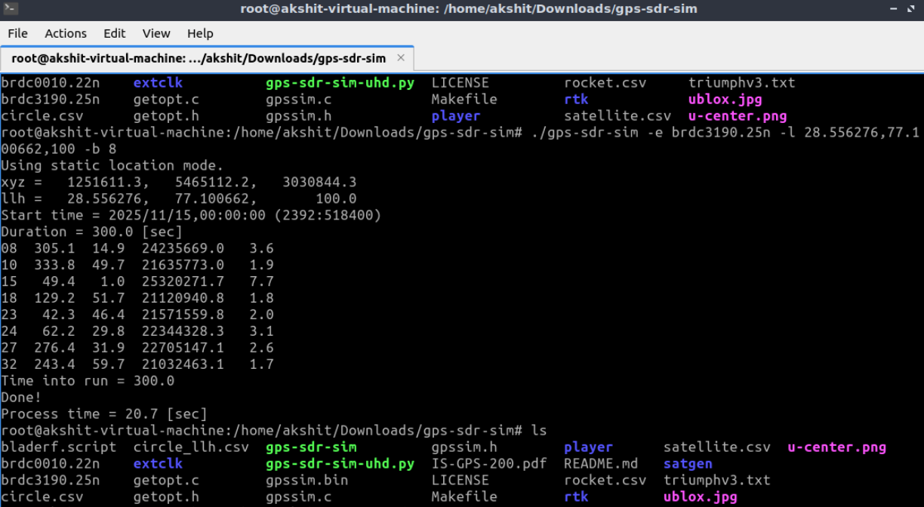
This produces:
gpssim.bin
This file contains the spoofed GPS simulation waveform for ~300 seconds (default duration).

8. Preparing HackRF One
8.1 Updating Firmware
Mayhem firmware updated via:
https://hackrf.app/
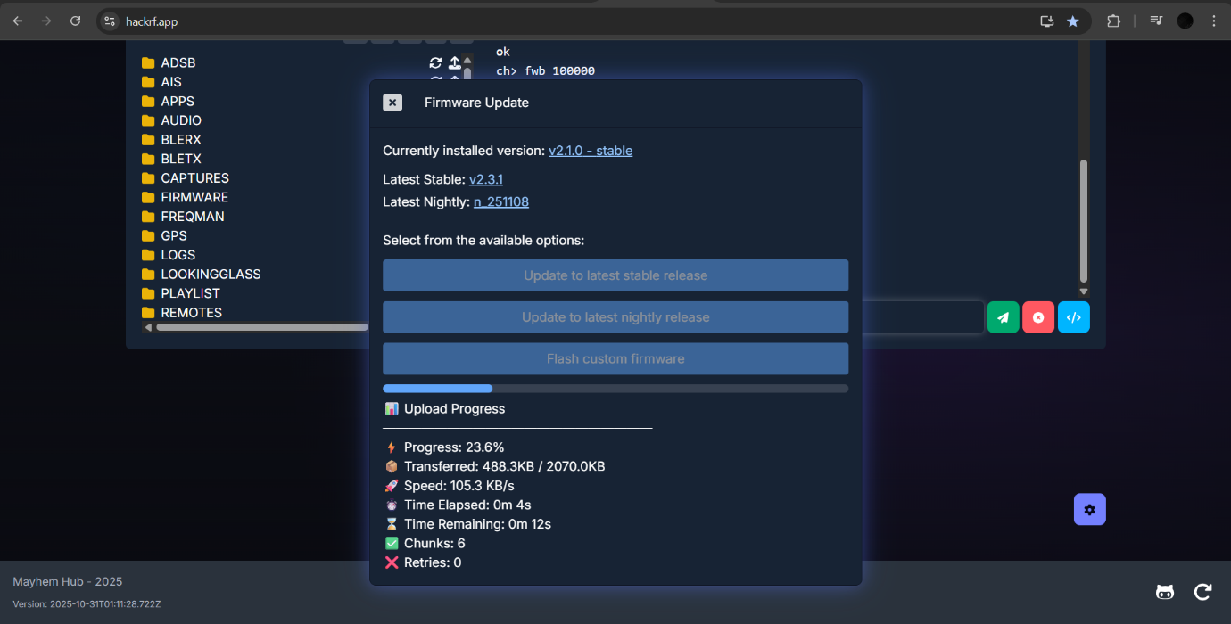
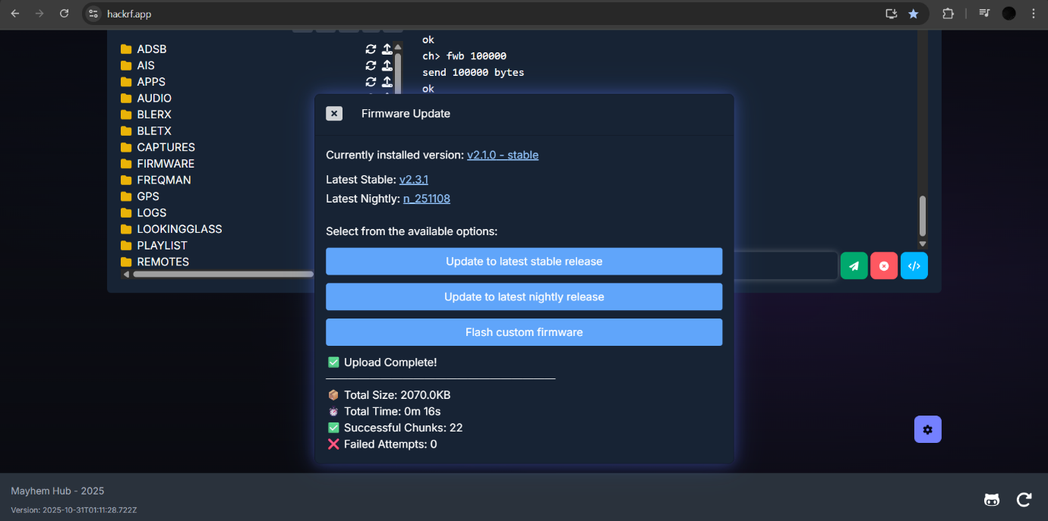
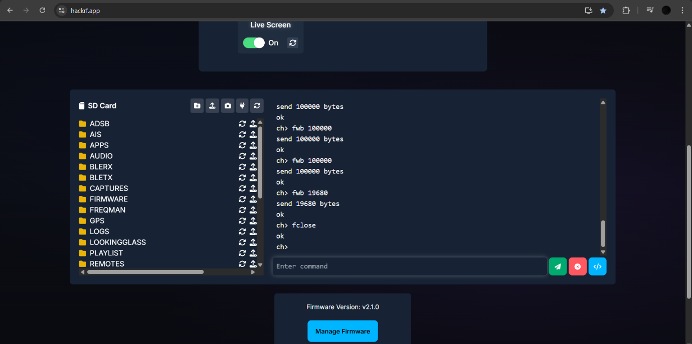
8.2 Verifying HackRF
hackrf_info
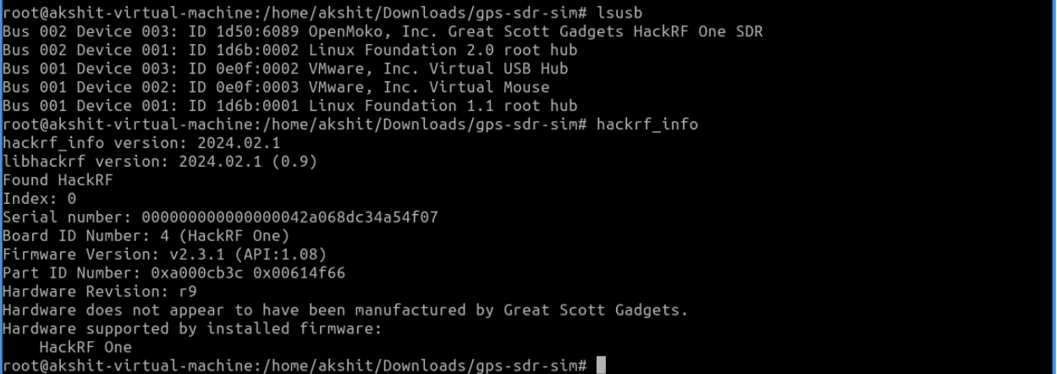
Device should be detected.

9. Transmitting the Spoofed GPS Signal
9.1 Transmission Command
hackrf_transfer -t gpssim.bin -f 1575420000 -s 2600000 -a 1 -x 0
Parameter explanation:
- -t gpssim.bin → The spoofed GPS waveform
- -f 1575420000 Hz → GPS L1 frequency (1575.42 MHz)
- -s 2600000 → Sample rate
- -a 1 → Enable amplifier
- -x 0 → TX gain (set to 0 for safety)
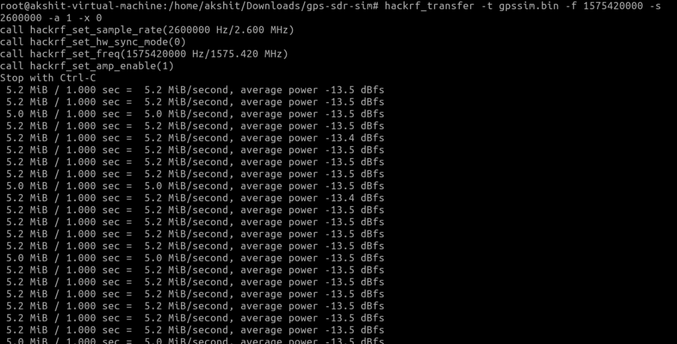
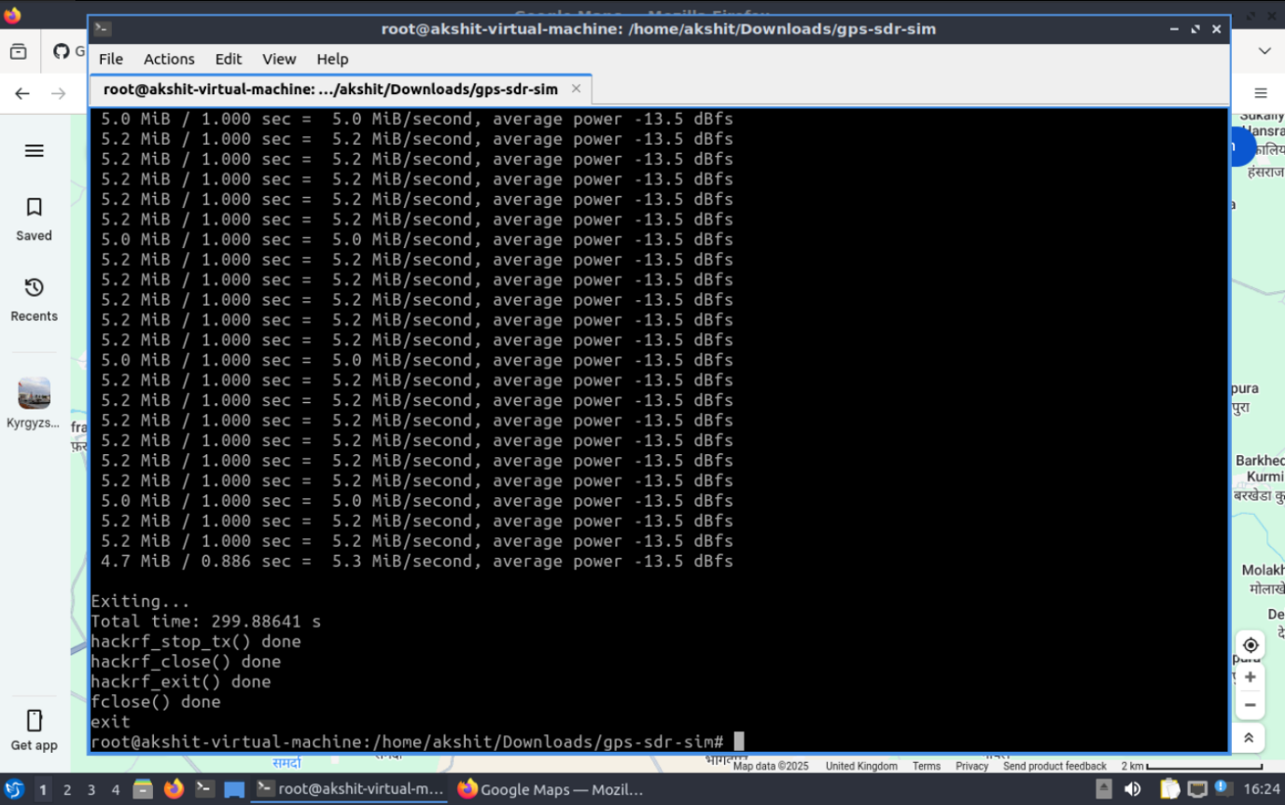
In a real environment, a GPS antenna will radiate these signals, which can overpower authentic GPS signals nearby.
Here, this was done only inside an RF-isolated environment.
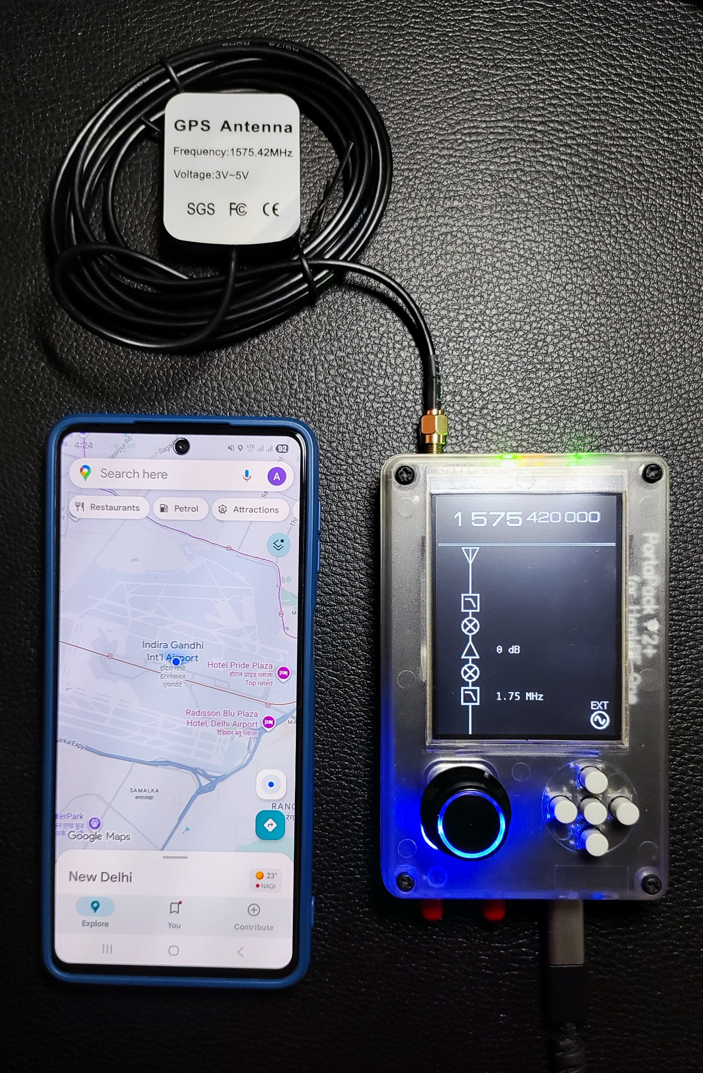

10. Aviation Security Implications
This demonstration highlights critical aviation concerns:
✔ Aircraft rely heavily on GNSS
Spoofed GPS signals can mislead:
- Aircraft navigation systems
- Flight management systems
- ADS-B receivers
- Ground control navigation aids
✔ Growing real-world incidents
Recent GPS spoofing has been reported in:
- Middle East
- Mediterranean
- India (Delhi, Ladakh region)
- China
- Russia/Ukraine region
✔ Need for better protections
Airports and aviation agencies must:
- Deploy GNSS interference detection
- Use multi-constellation GNSS
- Add receiver authentication / RAIM+
- Rely on redundant navigation systems (INS, VOR/DME)

11. Conclusion
This research project demonstrates how GPS spoofing works at a technical level and why modern aviation systems must implement robust countermeasures.
Using accessible tools like HackRF and GPS-SDR-SIM, it becomes clear that GPS spoofing is no longer theoretical — it is a practical threat.
Aviation authorities, cybersecurity professionals, and GNSS engineers must work together to enhance GPS integrity and ensure safe navigation for all aircraft.

- Real-Time Aircraft Tracking Using SDR: ADS-B and Mode S Decoding
To complement the GPS spoofing research, a real-time aircraft tracking system was also developed using Software-Defined Radio (SDR). This system receives, decodes, and analyzes ADS-B (Automatic Dependent Surveillance–Broadcast) and Mode S transponder signals transmitted by aircraft at 1090 MHz. The goal of this project is to understand how aviation telemetry works — and how GPS spoofing can influence ADS-B data downstream.

12.1 Project Description
A real-time aircraft tracking system was built using HackRF One, DragonOS, and SDR Angel to monitor aircraft positions, velocities, altitudes, ICAO identifiers, and other telemetry broadcast by aircraft within listening range.
This system demonstrates how aircraft navigation and surveillance heavily depend on GNSS correctness — making it directly relevant to GPS spoofing research.

12.2 Steps and Achievements
1. Hardware Setup
- Used HackRF One with PortaPack H2+
- Operated inside a DragonOS environment with SDR tools preinstalled
- Attached a 1090 MHz antenna for optimal aircraft signal reception
2. Software Configuration
- Configured SDR Angel to:
  - Tune to 1090 MHz
  - Receive ADS-B and Mode S transmissions
  - Set appropriate sample rate for PPM demodulation
3. Signal Optimization
- Adjusted:
  - LNA (Low Noise Amplifier)
  - VGA (Variable Gain Amplifier)
to maximize signal clarity
- Ensured minimal noise for clean decoding
4. Demodulation and Decoding
- Added ADS-B Demodulator Channel in SDR Angel
- Successfully decoded:
  - Aircraft latitude & longitude
  - Altitude
  - Velocity
  - Heading
  - Squawk code
- Decoded Mode S 24-bit ICAO addresses to uniquely identify aircraft
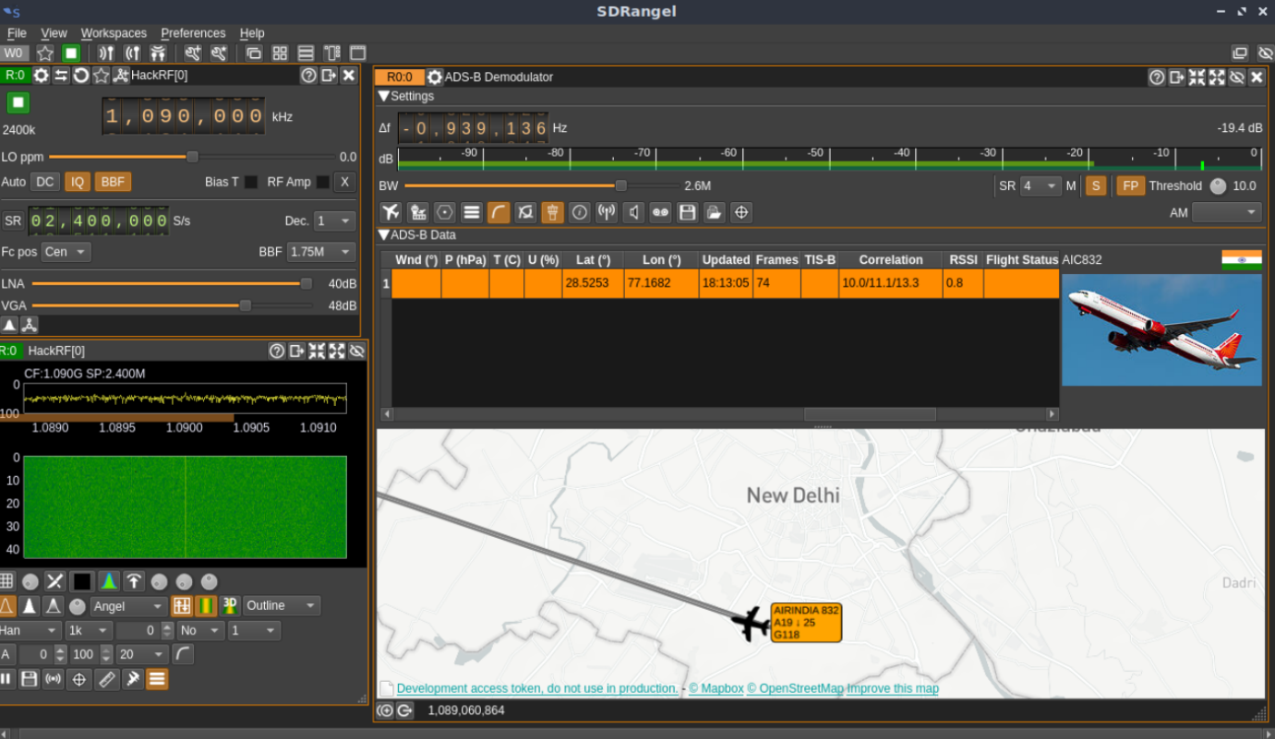
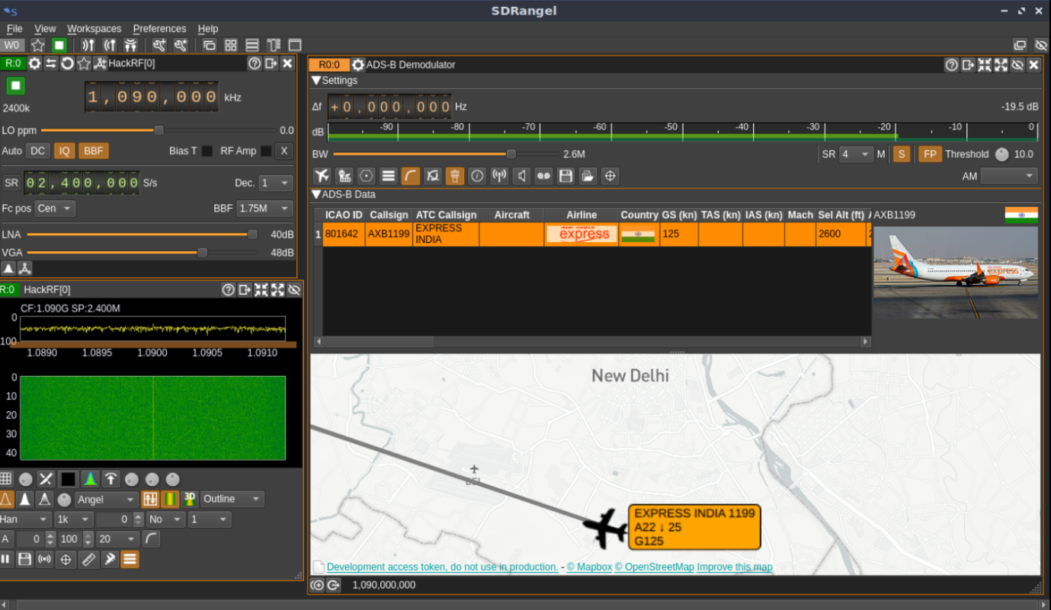
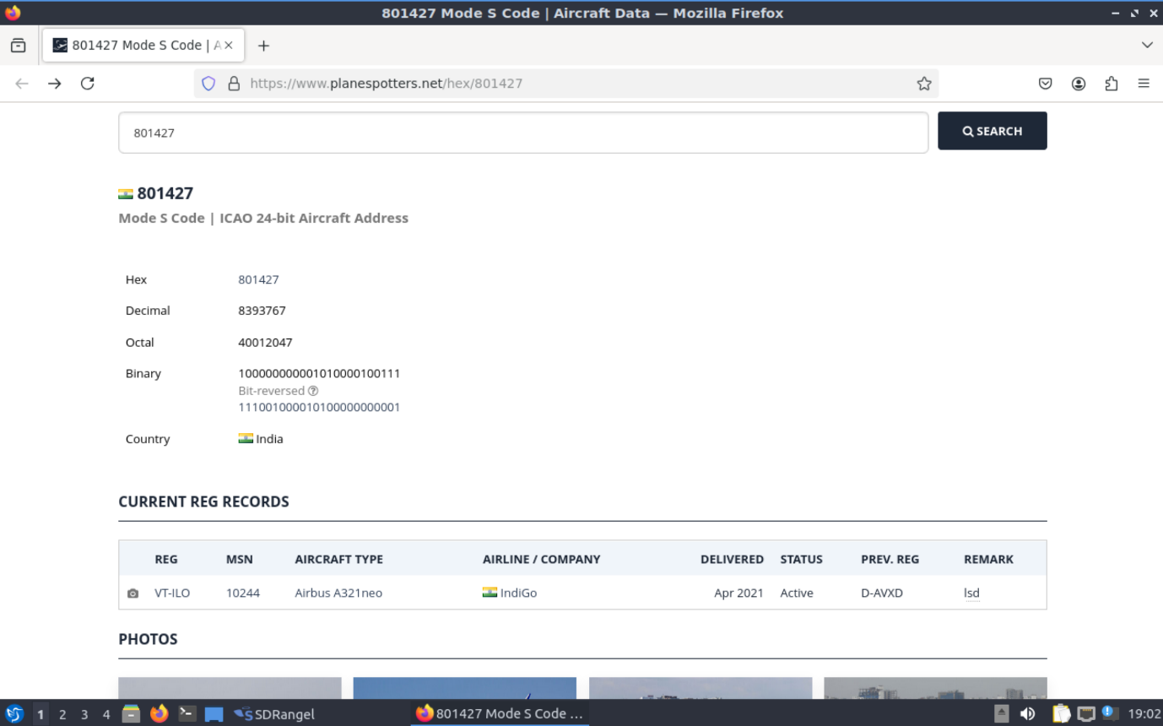
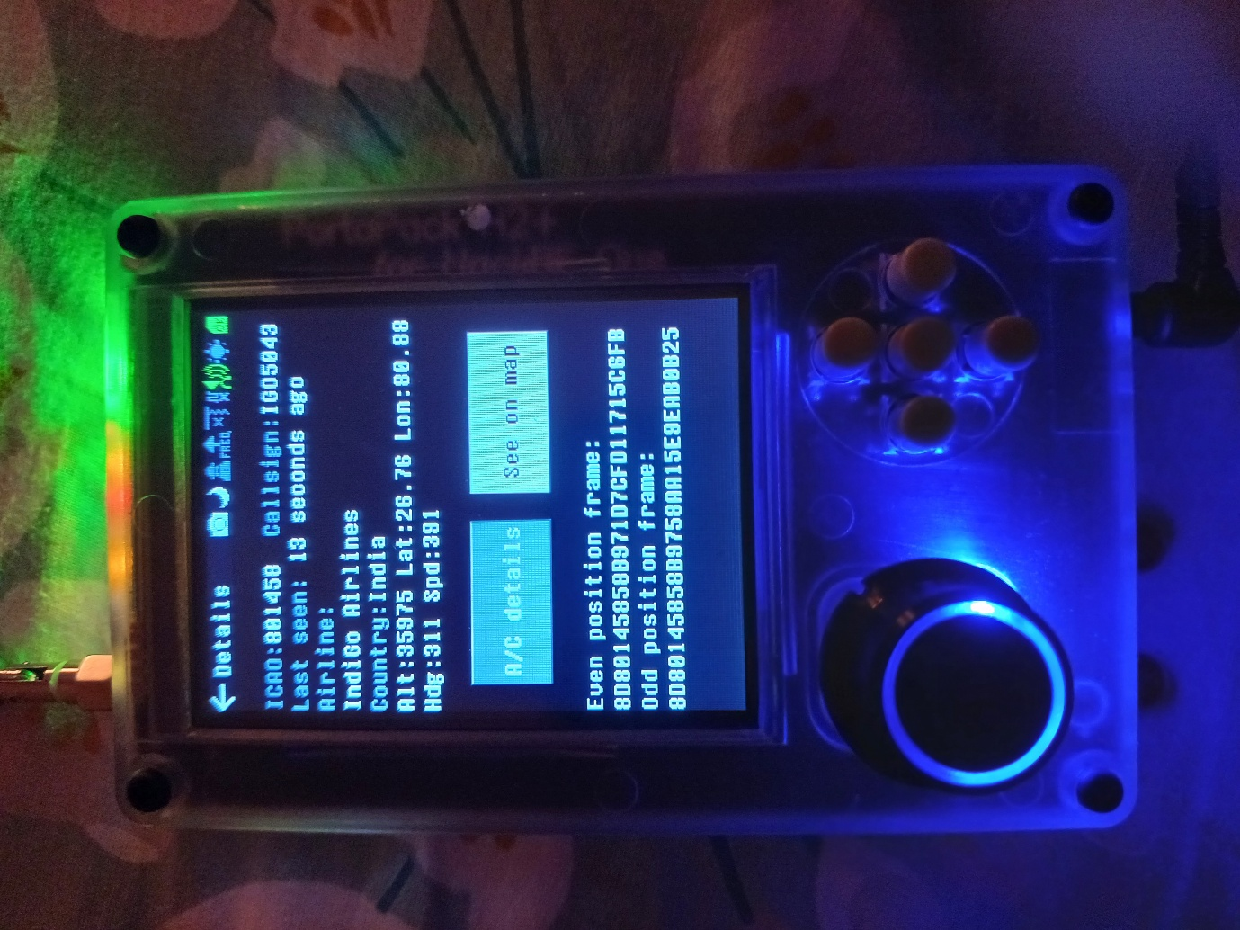
5. Visualization
- Real-time aircraft data was displayed in SDR Angel, showing:
  - Aircraft telemetry
  - Flight movement
  - Transponder identity
  - Signal quality

12.3 Theory and Concepts
ADS-B (Automatic Dependent Surveillance–Broadcast)
- Aircraft broadcast their GPS-derived position multiple times per second
- Uses Pulse-Position Modulation (PPM)
- Broadcasts:
  - Position
  - Velocity
  - Identification
  - Navigation status
Mode S Transponders
- Provide aircraft identity (24-bit ICAO code)
- Used by ATC for tracking and interrogation
PPM Demodulation
- ADS-B messages encode bits based on the position of pulses
- Requires precise timing and signal clarity
SDR (Software-Defined Radio)
- Allows flexible demodulation and real-time processing
- Capable of decoding aviation telemetry without specialized hardware

12.4 Skills Demonstrated
- SDR Signal Processing
- ADS-B & Mode S Decoding
- RF Gain Optimization
- GNSS-Based Telemetry Interpretation
- SDR Angel Configuration
- HackRF One Operations
- Aviation Cybersecurity Analysis

- Combined Attack Surface: Injecting GPS-Spoofed Coordinates into ADS-B Stream
With both systems operational —
- GPS Spoofing with HackRF One, and
- ADS-B/Mode S Real-Time Aircraft Tracking —
this research explored how spoofed GPS data can influence or mislead aviation surveillance systems by propagating into the ADS-B telemetry chain.

13.1 How GPS Spoofing Affects ADS-B
ADS-B depends on GPS-derived position.
If a GPS receiver receives spoofed GNSS signals, then:
✔ The aircraft’s internal system believes the spoofed GPS coordinates
✔ The aircraft then broadcasts those same fake coordinates via ADS-B
✔ ATC systems, flight trackers, and SDR receivers see incorrect aircraft locations

13.2 Combined Experiment Workflow
Step 1 — Generate Spoofed GPS I/Q Data
“./gps-sdr-sim -e brdc3190.25n -l 28.556276,77.100662,100 -b 8”
Step 2 — Transmit GPS Spoofed Signal
“hackrf_transfer -t gpssim.bin -f 1575420000 -s 2600000 -a 1 -x 0”
Step 3 — ADS-B Receiver Captures Modified Telemetry
Inside the RF test container:
- The GPS receiver locks onto the spoofed signal
- ADS-B/Mode S signals generated based on spoofed coordinates now reflect wrong locations
Step 4 — Real-Time Spoofed Location on SDR Angel
ADS-B visualization begins showing:
- Incorrect aircraft positions
- Incorrect velocities/headings
- Phantom movement patterns
- GNSS-induced telemetry errors

13.3 Findings
The combined system demonstrated:
✔ A spoofed GPS signal directly corrupts ADS-B positional data
✔ ADS-B has no authentication or GNSS integrity checks
✔ False aircraft locations can appear on tracking systems
✔ Airspace situational awareness can be misled
This highlights a critical vulnerability in aviation cybersecurity —
GNSS spoofing is not isolated to navigation; it cascades into surveillance, ATC workflows, and tracking systems.

